**Improving STEM Teaching Process using Digital Transformation - DIGSTEM**

supported by the Visegrad Fund

**Project Meeting**

Lublin University of Technology, Lublin, Poland

03rd-04th October 2023

Fundamentals of Technology Faculty (to 30th September 2023)

Faculty of Mathematics and Technical Computer Science (from 1st October 2023)

Address: Nadbystrzycka St. 38, 20-618 Lublin

**Moderators:**

PhD Eng. Michal Charlak, Lublin University of Technology

Dr. Vladimir Maksimovic, University of Pristina in Kosovska Mitrovica

**Consortium:**

University of Pristina in Kosovska Mitrovica - coordinator

Lublin University of Technology

Obuda University

University of Zilina

Universum College

|  |  |
| --- | --- |
| **Day 1 - Tuesday, 03rd October 2023** | |
| **09:00-09:30** | **Participants registration** |
| **09:30-09:45** | **Welcome and introduction**  *Michal Charlak, Lublin University of Technology*  *Vladimir Maksimovic, University of Pristina in Kosovska Mitrovica* |
| **09:45-11:00** | **Partner presentations**  *Stefan Pitulic, University of Pristina in Kosovska Mitrovica*  *Uran Rraci, Universum College*  *Michal Charlak, Lublin University of Technology*  *Viktor Gonda, Obuda University*  *Radovan Madleňák, University of Zilina* |
| **11:00-11:30** | **Project activities and timeline: Preparation of the DIGSTEM webinar and DIGSTEM publication**  *Jelena Todorovic University of Pristina in Kosovska Mitrovica* |
| **11:30-12:00** | **Project Management Issues: Administration and Budget**  *Vladimir Maksimovic, University of Pristina in Kosovska Mitrovica* |
| **12:00-12:45** | **Application of Wolfram Demonstration Project Platform in teaching**  *Izolda Gorgol, Lublin University of Technology* |
| **12:45-13:00** | **Break** |
| **13:00-15:30** | **Inauguration of the academic year of the Faculty of Mathematics and Technical Computer Science** (the newest Faculty at LUT) |
| **15:30-16:15** | **Challenges and Opportunities of Online Learning and Teaching at**  **Engineering at Obuda University**  *András Horváth, Obuda University* |
| **16:15-17:00** | **Online learning environment at University of Zilina**  *Radovan Madleňák, University of Zilina* |
| **17:00-17:30** | **General discussion and conclusions of the Day 1** |

|  |  |
| --- | --- |
| **Day 2 - Wednesday, 04th October 2023** | |
| **09:00-09:30** | **Participants registration** |
| **09:30-10:15** | **Possibilities of using Digital Transformation in the STEM Teaching Process**  *Michał Charlak, Lublin University of Technology* |
| **10:15-11:00** | **Digital communication tools for evaluation**  *Agnieszka Gandzel, Lublin University of Technology* |
| **11:00-11:45** | **Application of the Collaborative Workshop Module in Moodle for**  **Elearning of Forming Technologies Course**  *Viktor Gonda, Obuda University* |
| **11:45-12:00** | **Break** |
| **12:00-12:45** | **Office365 for students of Lublin University of Technology**  *Ewa Łazuka, Lublin University of Technology* |
| **12:45-13:30** | **Creation an Online Facilitate and Engaging Workshop Practice for**  **Students**  *Béla Mészáros, Obuda University* |
| **13:30-14:15** | **HMI-LAB and its usage for support of student**  *Radovan Madleňák, University of Zilina* |
| **14:15-15:00** | **The use of e-learning tools in the teaching of technical subjects at the University of Žilina (practical presentation)**  *Jiří Tengler, University of Zilina* |
| **15:00-15:15** | **Break** |
| **15:15-16:00** | **Study visit to LUT laboratory**  *Ewa Łazuka, Lublin University of Technology* |
| **16:00-17:00** | **Study visit to LUT laboratory**  *Michał Charlak, Lublin University of Technology* |
| **17:00-17:30** | **General discussion and conclusions of the Day 2** |

***Useful Information***

The study visit was held in the Faculty of Mathematics and Technical Computer Science, room 8 (1st floor)

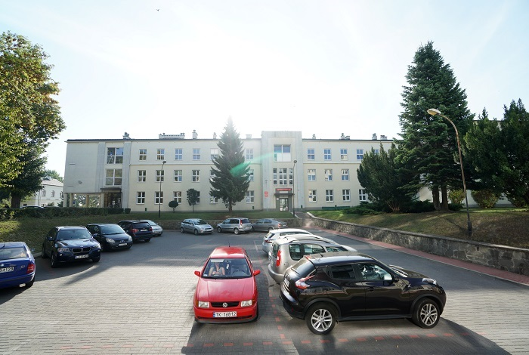

The Faculty building is located in the central part of the campus - building no. 10 on the map

<https://pollub.pl/uczelnia/o-politechnice/mapa-kampusu>